STAND UP TO BULLYING DAY
JUNE 21ST 2017

In support of Anti Bullying 2017, I hope you find the below
informative and useful.

Overcoming bullying can be one of the hardest things to do.
We often speak to friends, family or adults who bear the scars of childhood
bullying. They may have trust issues, low self-esteem and self-worth.
The effects of bullying can determine someone’s behaviour and
actions. For those who have experienced bullying, it may be difficult to
do the everyday things we take for granted, such as meeting new
people, trying out new experiences and challenges and more.
In a most recent anti-bullying survey of November 2016, it found that
almost 9,000 respondents highlighted that bullying remains a key area
of concern for young people, pupils, parents and education
professionals and continues to impact negatively on those it affects.

There are many myths surrounding bullying and some of these
myths suggest a big deal is being made out of nothing when that is not
the case. We believe it is important to address bullying whether its
name calling, social bullying between friends, at school or in the neighbourhood.
It is not uncommon for people to experience some form of verbal bullying at some point in their lives. Many young people we speak to
hear insults on a daily basis when they are in school or in a social
setting. It is difficult to understand why someone would want to use
insults towards others. They might be doing this to impress their
friends or build up some type of reputation. They may have been
bullied themselves and to deflect the attention or because they are
angry, they go onto bully someone else. They might be having
problems at home or at school so they are taking this out on someone
else
Being socially bullied is also known as covert and relational bullying as
it is designed to humiliate and damage someone socially. It includes lying, fake rumours and spreading gossip and encouraging others to
turn against someone. It isn’t easy for someone going through this to
accept when the line crossed from being a prank or banter to
persistent bullying.

It’s vital that we tackle bullying as a society to ensure its effects do
not permeate throughout an entire lifetime and affect and damage
future experiences and relationships.
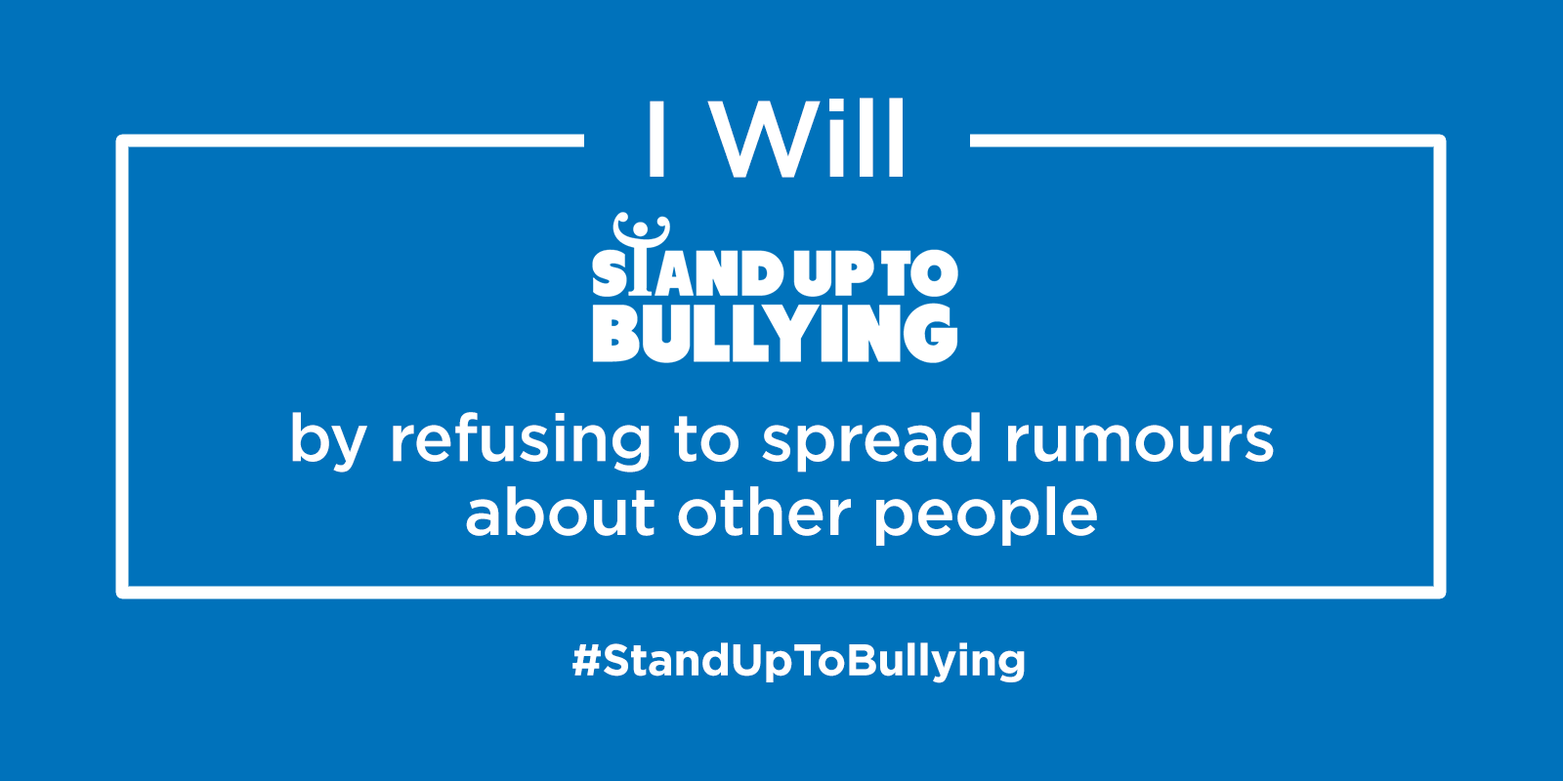

Today and any day please make a stand against bullying. Please feel free to display the pledge in your form.
There are various websites to help you or your fellow pupils if you feel you need support.
The important thing is to share it with your friends, your family, your HALS or any member of staff you trust and feel comfortable with.
Do not suffer alone and ask for help.
Mrs Fairhurst
Safeguarding & Intervention. June 2017
Follow on Twitter
@DianaAward
@AntiBullyingPro
Like us on Facebook
Facebook.com/TheDianaAward
Facebook.com/AntiBullyingPro
Follow on Instagram
@DianaAward
@AntiBullyingPro
Happy #StandUpToBullying Day
The Diana Award Team

